EMCH 308 Project 1 Team 3 I-Beam Report
For steel truss with a line failure stress of 400 megapascals (MPa) having a line load of 1000 newtons per meter (N/m) applied over a one-meter segment at its rightmost end, it was determined that, if steel I-beams were used in construction, that a Von Misses stress no greater than 2.607*10^8 pascals (Pa) could be achieved with a cross-sectional area of 1.596*10^-4 meters square (m^2). Von Misses stress was chosen over the Maximum inplane stress because it accounts for stresses acting in all three dimensions (3D) while the max inplane stress accounts for only two dimensions (2D). The dimensions were chosen via trial and error and are shown in figure 1.
Figure 1 crossectional dimensions of the I-Beam:
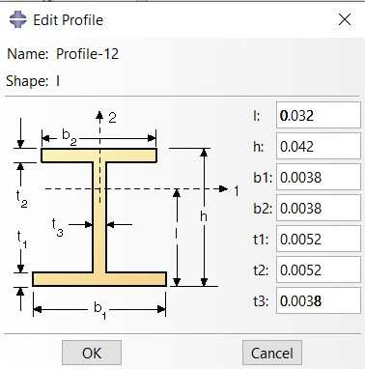
While the profile is technically an I-Beam in reality it looks more like an H-Beam.

